K.BHANUTEJA

192111320

OOAD LAB EXPERIMENTS **DAY-1**

**1**.**Develop a system using UML for Passport Management System, It should verify the passport details of the applicant by the central computer. The details regarding the passport will be provided to the central computer and the computer will verify the details of the applicant and provide approval to the office. Then the passport will issue from the office to the applicant.**

**AIM:-**

To develop a system using UML for passport management system.

UML DESIGNS:-

1.USE CASE:

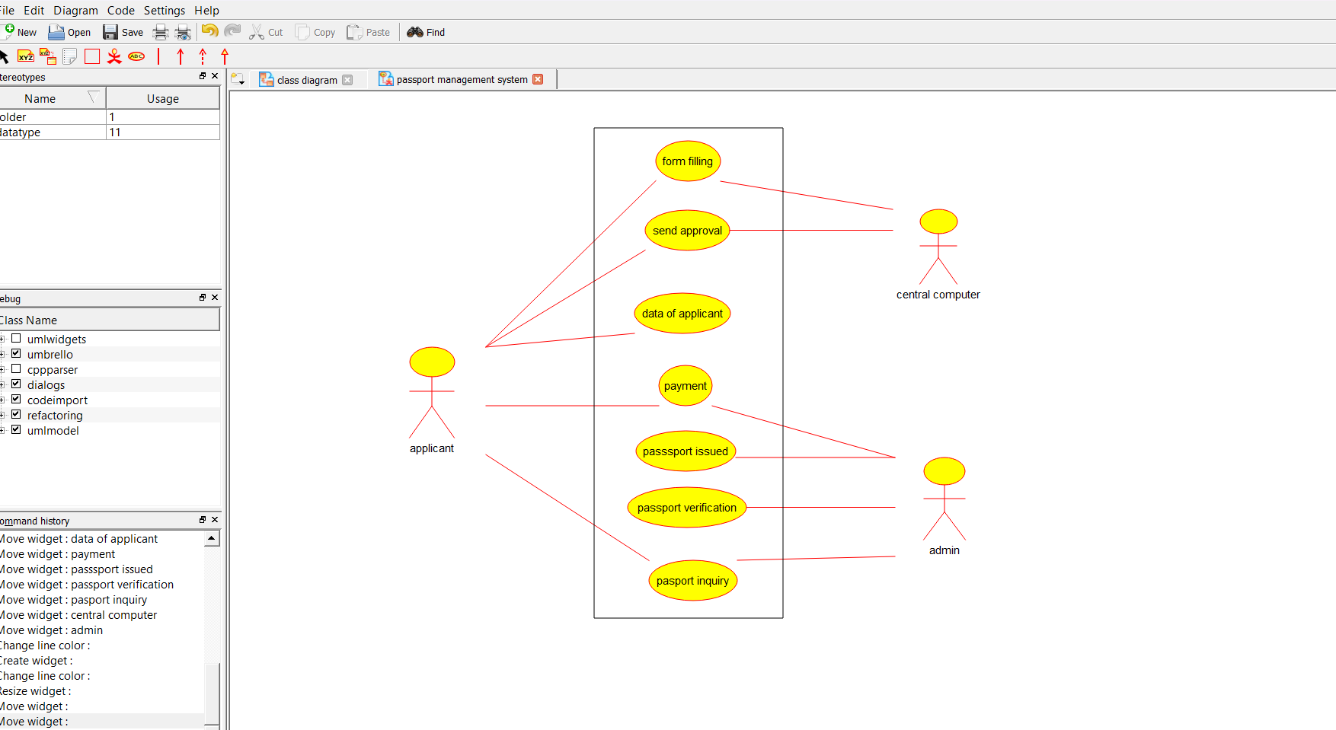

2.CLASS DIAGRAM:

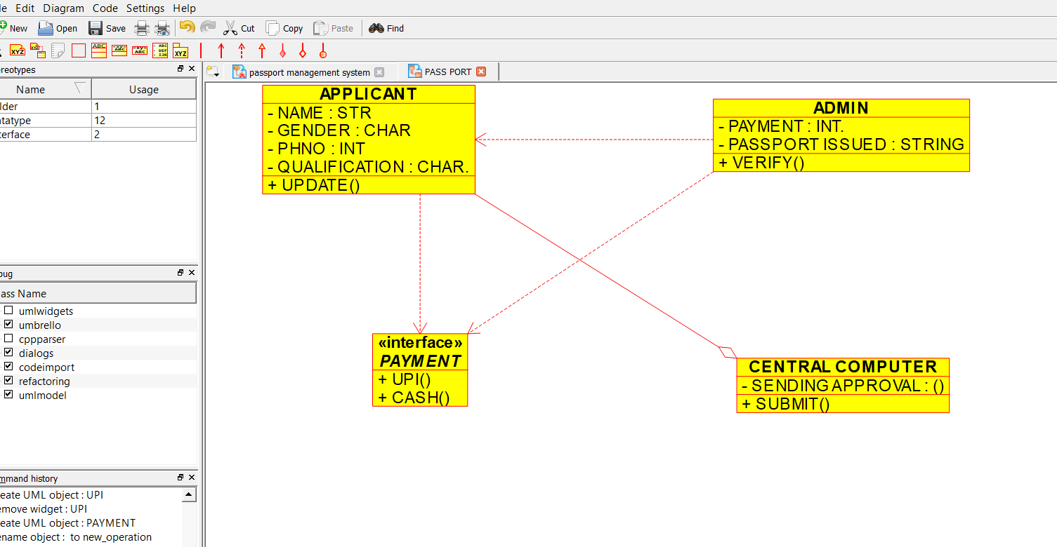

3.SEQUENCE DIAGRAM:

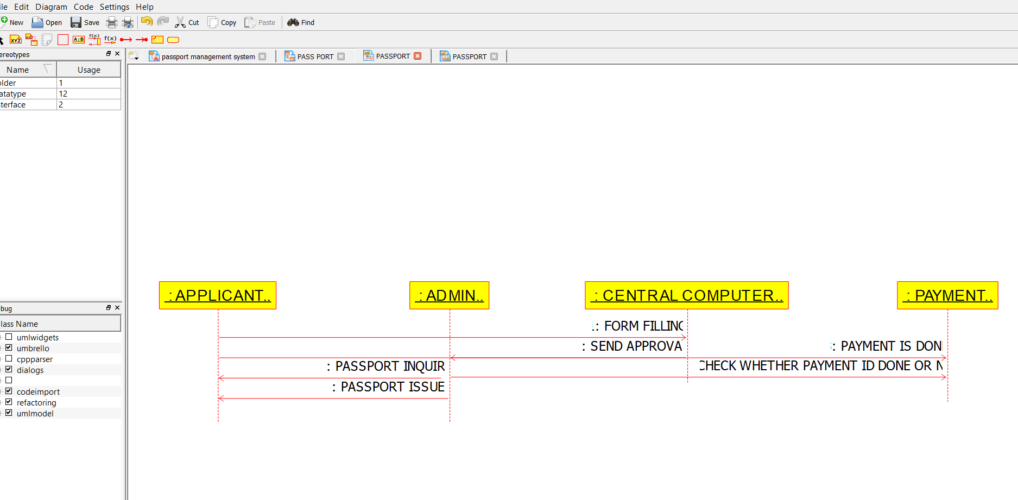

**2.** **Develop a system using UML for implementing the Book Bank process. It should verify the details of the student by the central computer. The details regarding the student will be provided to the central computer through the administrator in the book bank and the computer will verify the details of the student and provide approval to the office. Then the books that are needed by the student will issue from the office to him**.

**AIM:-**

To develop a system using UML diagrams for BOOK BANK PROCESS.

UML DESIGNS:-

1.USE CASE:

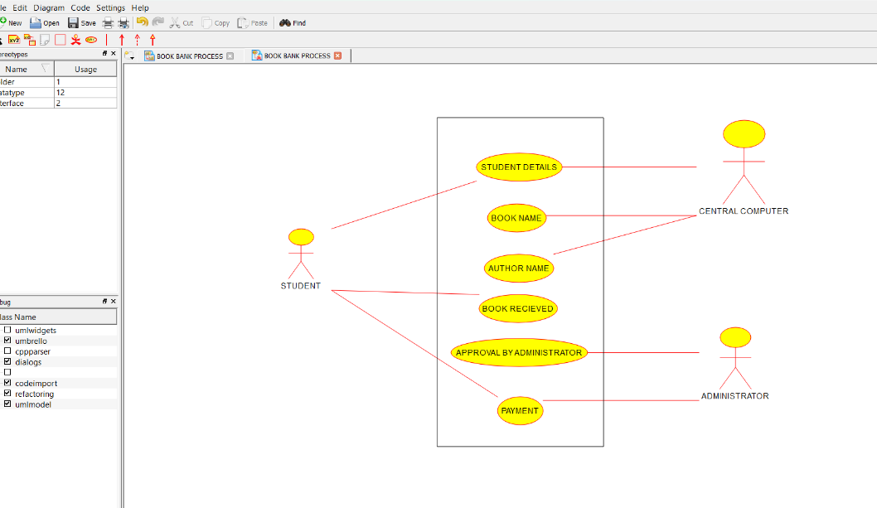

2.CLASS DIAGRAM:

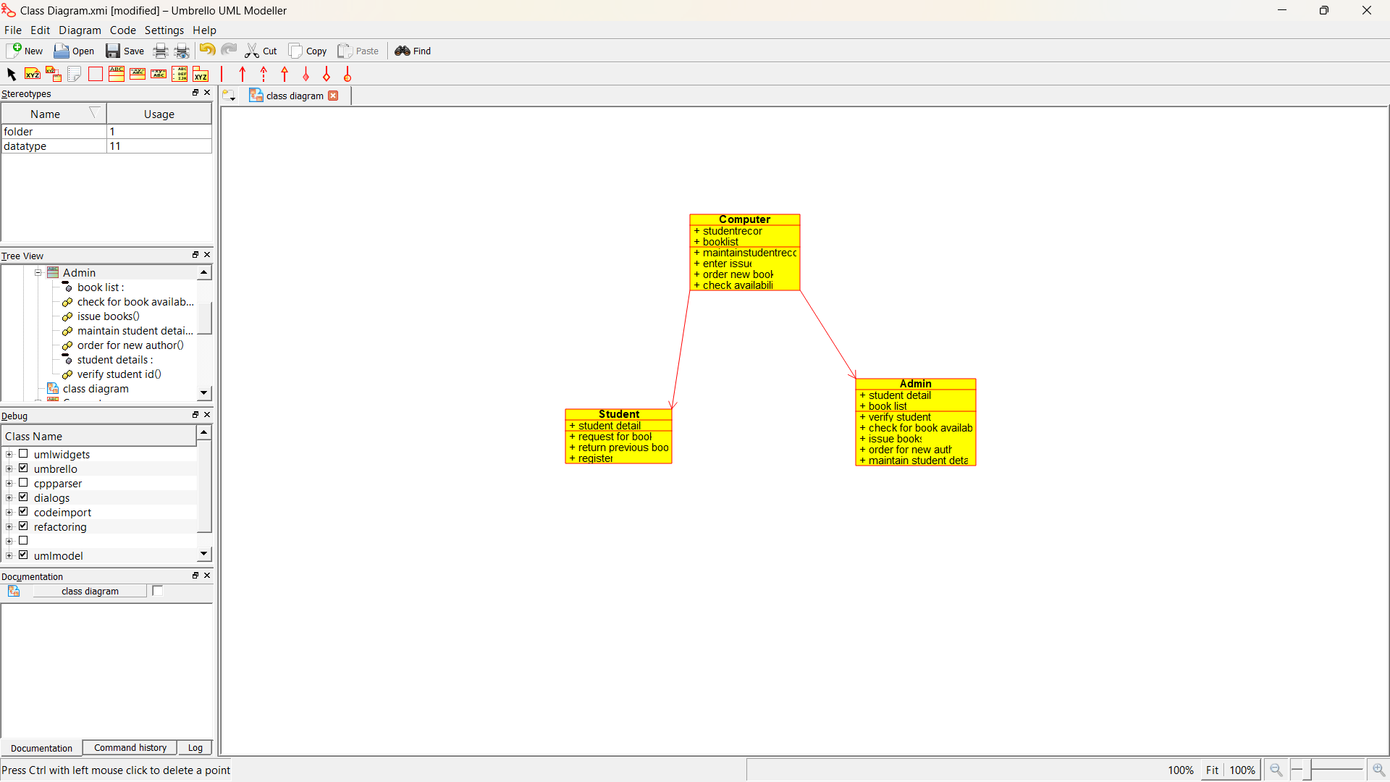

3.ACTIVITY DIAGRAM:

